**IMPLEMENTATION**

This project has been implemented using Node JS. Node.js is a powerful and versatile JavaScript runtime environment that allows you to execute JavaScript code outside of a web browser. It's designed to build scalable network applications.

**Back-End Development**

1. The Node JS runtime environment allows the developers to write code logic to run on the server side,
2. The server-side code is the one that connects to the database and queries it accordingly,
3. The Database Management System that we are using is MySQL which is deployed on an Apache Tomcat Server Trough XAMPP- XAMPP is a popular software package that allows you to set up a local web server environment on your computer. This is useful for testing and developing web applications without needing to deploy them to a live server,
4. The Back-end code receives and handles all the server requests and responds accordingly.

**Back-End Source code Directory**: The entry point begins with the **index.js** file located in the root directory. The rest of the back-end logic is located in a folder called **BACK_END** as illustrated below:

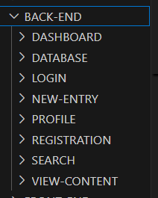

Figure BACK-END DIRECTORY

Each feature is placed into its own folder, this makes it simpler to manage features and is generally a good practice as it is a scalable structure and if one of the features breaks it can be isolated from the rest of the web app.

**Front-End Development**

1. The web app uses **Handlebars** view engine. The view engine is a templating tool that renders client-side HTML, CSS and JS dynamically and because of this the HTML file extensions must end with ‘**.hbs’** extension as illustrated:
2. 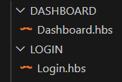There are two directories associated with the client-side code. These are the ‘**static’** directory and ‘**FRONT-END’** directory. The static directory contains the CSS files as well as image assets. Both directories are in the root folder od the source code

Figure Handlebars file Extension

1. 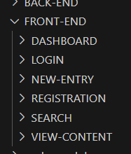The FRONT-END directory contains all the client-side code and inside it all the features are also contained into separate folders just like with the back-end:

Figure FRONT-END Directory